NEW SUMMIT COLLEGE
Shantinagar Gate, Kathmandu (Affiliated to Tribhuvan University)


Lab report of
OPERATING SYSTEM
CSC 264
Bachelor of Science in Computer Science and Information Technology Institute of Science and Information Technology

Submitted by: Submitted to:
Name: AMIR BHATTARAI Name: APIL ADHIKARI
Symbol no: 80010527 Sign: …………………......
Reg. no: 5-2-476-71-2023
Semester: 4th


NEW SUMMIT COLLEGE OPERATING SYSTEM(CSC 264)
INDEX
SUBMITTED BY: AMIR BHATTARAI

S.N. | TITLE | Practical Date and Sign | Submission Date and Sign

OUTPUT:

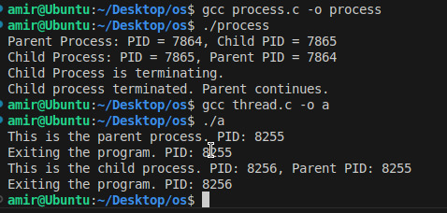

OUTPUT:



OUTPUT:

